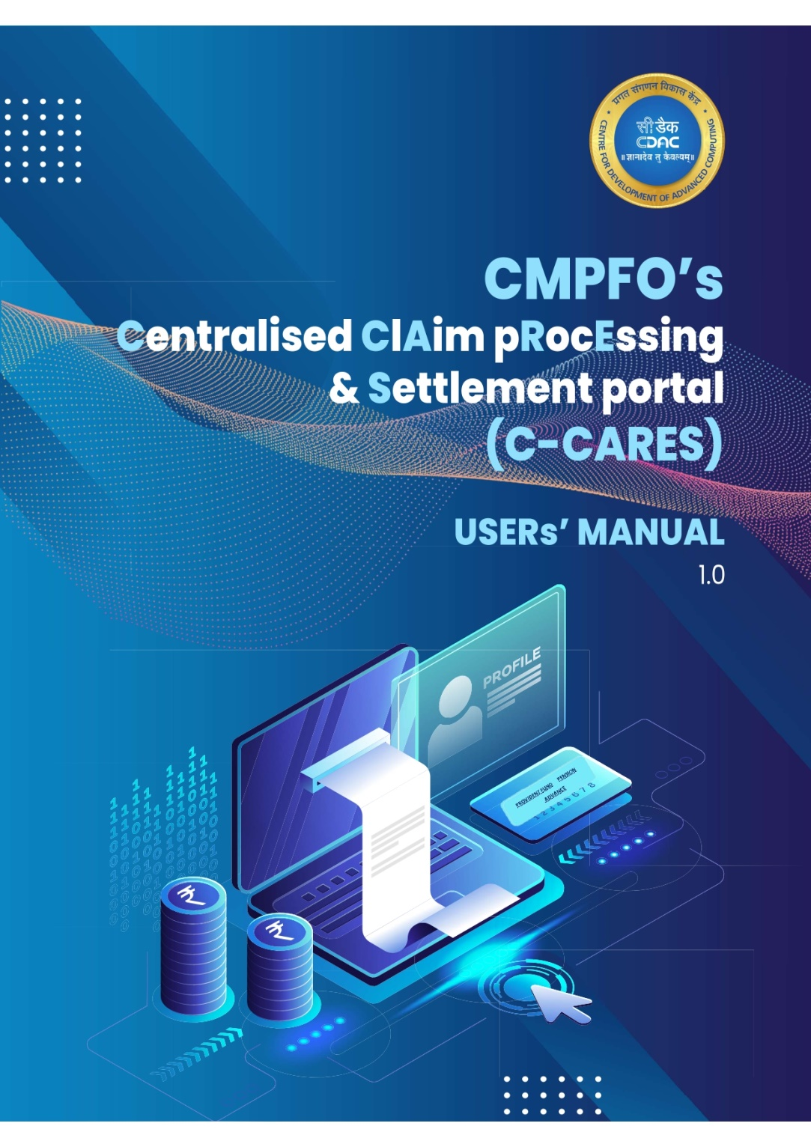

This page is intentionally left blank.

Table of Contents

1 AN OVERVIEW OF C-CARES ..…………………………………………………. 4

**1.1 Purpose of the Document ………………………………………………………. 5**

**1.2 System Overview ……………………………………………………………………. 5**

**1.3 Contact ………………………………………………………………………………….. 5**

2 GETTING STARTED ………………………………………………………………… 6

**2.1 System Requirements …………………………………………………………….. 6**

**2.2 Accessing C-CARES Portal ……………………………………………………….. 6**

**2.3 Member Enrolment ………………………………………………………………… 7**

**2.3.1 Member Enrolment Guidelines ……………………………………… 10**

**2.4 Member Login ………………………………………………………………………… 12**

**2.4.1 Member Login Guidelines ……………………………………………… 15**

3 MEMBER DASHBOARD ………………………………………………………….. 18

**3.1 Account Summary ………………………………………………………………….. 18**

**3.2 PF Statement …………………………………………………………………………. 18**

**3.2.1 Declaration of Correctness ……………………………………………. 20**

**3.3 Change Password …………………………………………………………………… 22**

**3.3.1 Change Password Guidelines …………………………………………. 24**

**3.4 View Profile ……………………………………………………………………………. 25**

**3.5 Add Family Member ………………………………………………………………. 25**

**3.6 View Family Member ……………………………………………………………… 25**

**3.7 Forgot Password …………………………………………………………………….. 26**

**3.7.1 Forgot Password Guidelines ………………………………………….. 29**

APPENDIX-A: Frequently Asked Questions ………………………………. 30

# 1. An Overview of c-cares

C-CARES Portal is envisioned to enable CMPFO and its regional offices, process and track the claims of the members w.r.t. Provident Fund, Pension and PF Advance and enable the employees to view their PF balances and the status of their claims. Additionally, it also has the details of the family members/nominees of the employee.

One of the most significant uses of this platform is that it brings down the burden of manual claim settlement of the employee by CMPFO and digitally makes available all information pertaining to employees and their claims.

C-CARES for CMPFO serves as a single access point for CMPFO and its regional offices as well as CIL Subsidiaries to access the employees’ database as well as offer the requisite claims-related services to employers and their respective employees. These services are accessible through APIs provided within the portal. The APIs interact with the Data Repositories configured in the portal to fetch the data and serve user’s request.

Additionally, the portal serves the purpose of bridging the gap between the employers and the employees as it offers transparency in the CMPFO processes by enabling the members to view their PF balances online. Additional feature of tracking the processing of the claim adds another level of transparency.

This detailed User Manual is the technical communication document that will assist CMPFO and its regional officers and its employees with the operation of C-CARES Portal. The User Manual will be updated as and when new features/functionalities are added to the C-CARES Portal.

## **1.1** Purpose of the document

The primary objective of this document is to facilitate convenient and efficient access to the portal for CMPFO and its stakeholders including the CIL Subsidiaries.

## **1.2** system overview

The following functionalities have been implemented on the C-CARES Portal:

* 1. **Enrolment & Login**
     1. Enrolment of a Member on C-CARES Portal
     2. Login mechanism for members
     3. Login for CMPFO/CC officials
     4. Forgot Password for Officers/Members
     5. Change Password for Officers/Members
  2. **View PF Balances**
     1. View PF Statements of Member
     2. Submit Consent for Correctness/Incorrectness of data
  3. **View Submitted Consents**
     1. View the consents by CC Official
     2. Redirecting consents to respective CC
  4. **Raise Grievance**
     1. Raise online grievance by the member

## **1.3** contact

The contents of this website are maintained by CMPFO. In case of any ambiguity or doubts, users are advised to contact on below email addresses.

For Grievances: **grievance@cmpfo.gov.in**

For Other Queries/Information: **support@cmpfo.gov.in**

# 2. getting started

## **2.1 System requirements**

**Hardware Requirements**

It can be accessed on most of the electronic devices like computers, laptops, tablets & mobile phones that have internet connectivity, with 16GB or more internal storage space and 4GB or more RAM size.

**Software Requirements**

Compatible Operating systems like Windows, iOS, Android etc. with latest versions of web browsers such as Chrome, Safari, and Microsoft Edge etc.

## **2.2 accessing C-cares portal**

C-CARES Portal can be accessed easily by any user. To access the C-CARES Portal, open any internet browser (i.e. Chrome, Microsoft Edge, Safari etc.) and type the following URL https://cmpfo.gov.in on the browser’s address bar. (Figure 1)

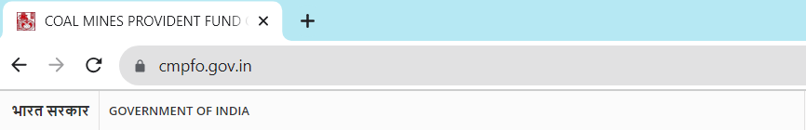

Figure 1: URL of CMPFO website

This takes you to the Home Page of CMPFO portal as shown in Figure 2, which hosts the links to access the C-CARES Portal.

## **2.3 member enrolment**

Each member of CMPFO and coal companies is required to enrol on the portal. C-CARES follows a simple yet effective enrolment process in order to authenticate and authorize the users. Successful enrolment of the user allows them to subsequently login to the portal and perform the respective tasks as defined in the CMPFO processes.

1. Click on Member Enrolment at the Home page. (Figure 2)

Figure 2: CMPFO’s Home Page

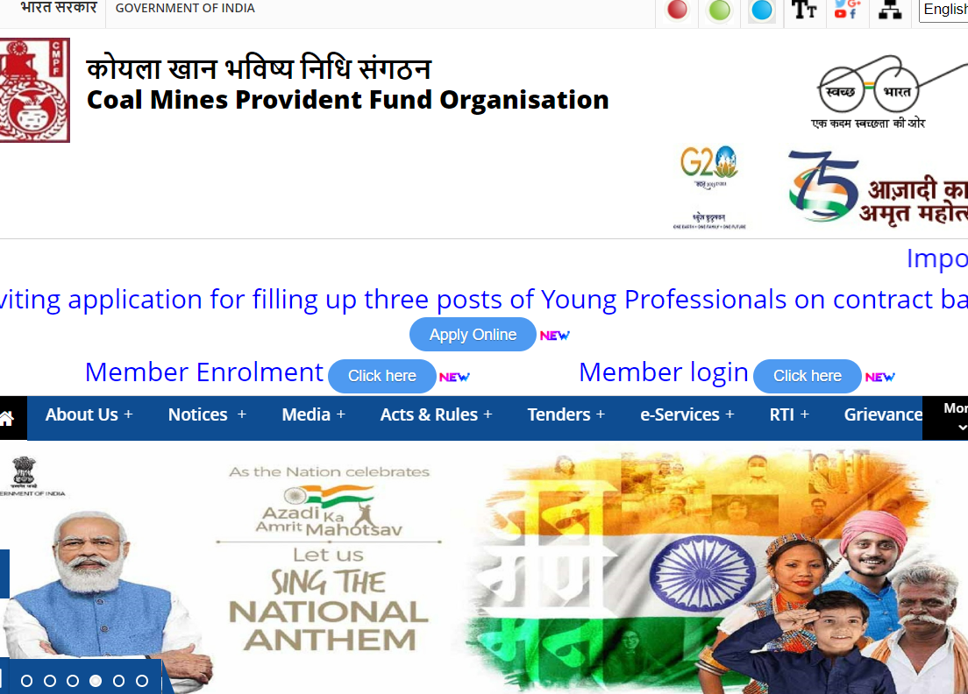

1. On the Member Enrolment page, (Figure 3), enter the correct CMPFO account number.
2. On entering the correct Account number other fields appear, like New Password, Confirm Password and Enter Captcha (Figure 4). Please enter the new password in accordance to the password guidelines.

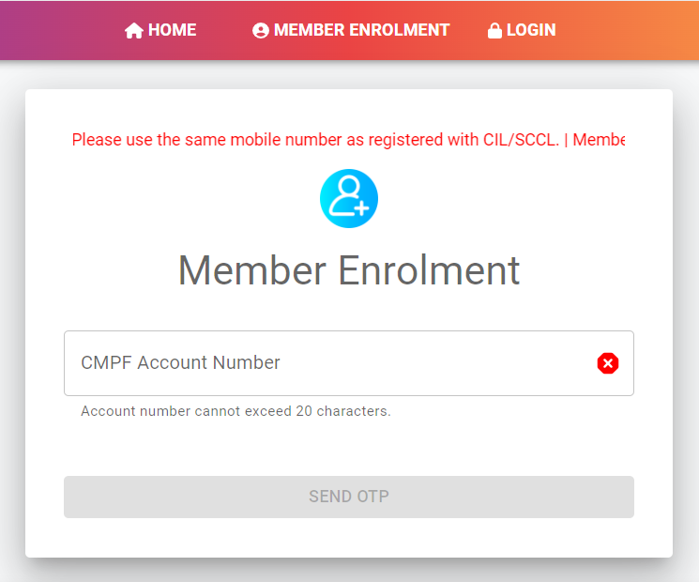

Figure 3: Member Enrolment

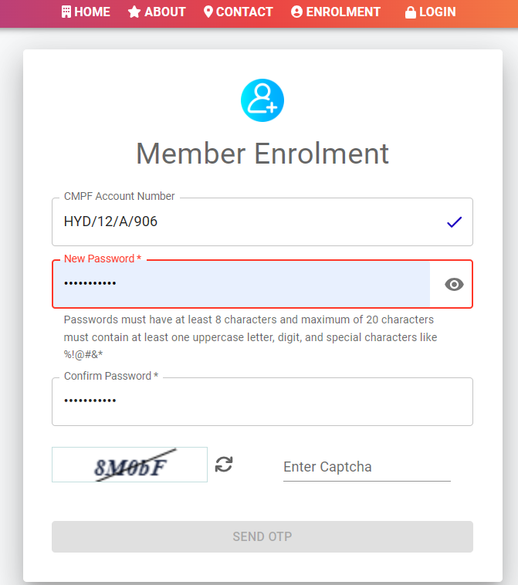

Figure 4: Enrolment Details

1. Enter the correct CAPTCHA. As soon as member enters the correct Captcha, ‘Send OTP’ button (orange in colour) gets activated. Click on Send OTP. (Figure 5)

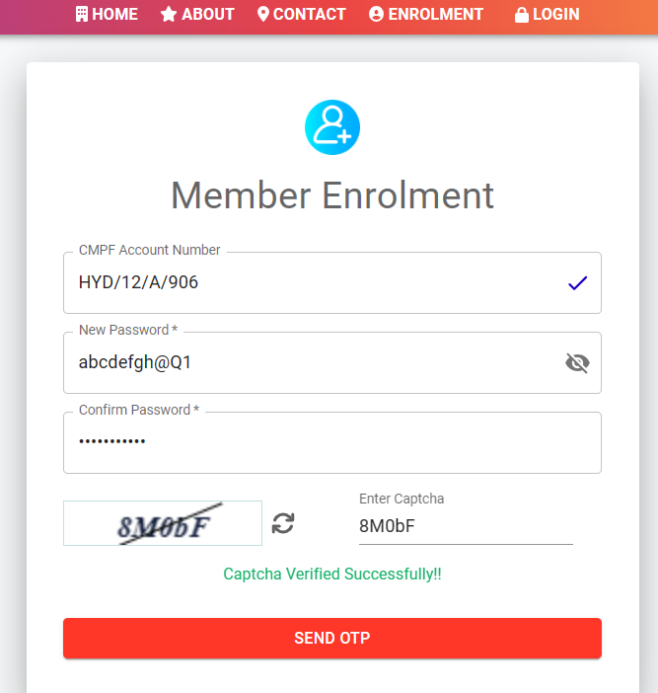

Figure 5: Captcha

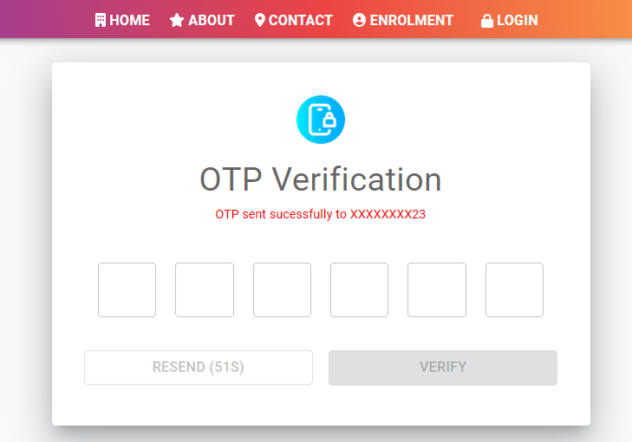

Figure 6: OTP Verification Page

1. An OTP is sent to the member’s registered mobile number. If OTP is not received within 60 seconds, the member can click on Resend OTP to receive the OTP again. “Resend” is enabaled not more than two times. (Figure 6)
2. Enter the OTP correctly and press VERIFY button. On successful OTP verification, member is enrolled and can proceed to LOGIN page. (Figure 7)

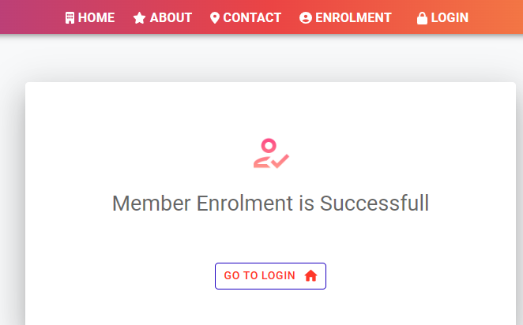

Figure 7: Successful Enrolment

### 2.3.1 member enrolment guidelines

For setting password, a standard format should be followed which mandates:

“Password must contain at least 8 characters and maximum of 20 characters, including uppercase, lowercase, number and special character except space.”

New Password and Confirm Password should be same, or else “Passwords do not match” error is shown. (Figure 8)

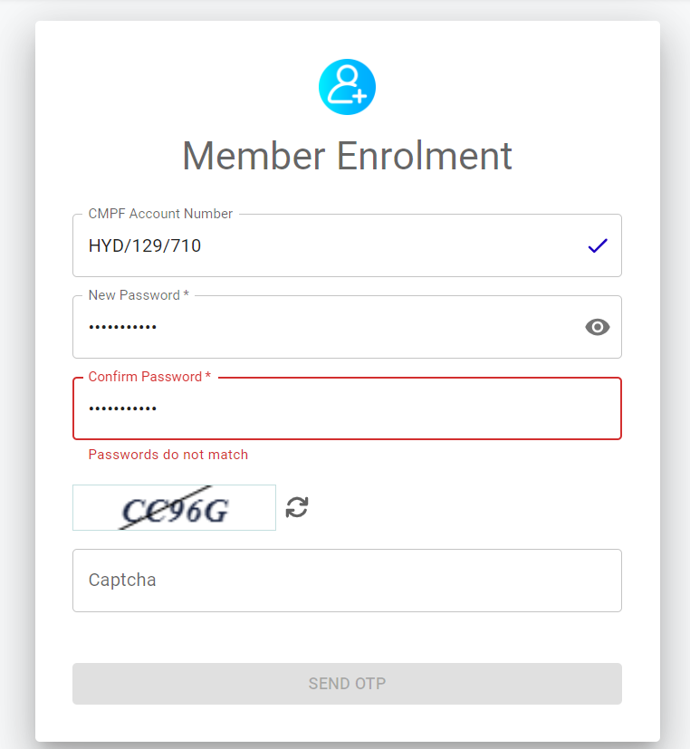

Figure 8: Password Mismatch

Member can make maximum of 3 attempts to enter OTP correctly, after which account gets blocked for 10 minutes. (Figure 9).

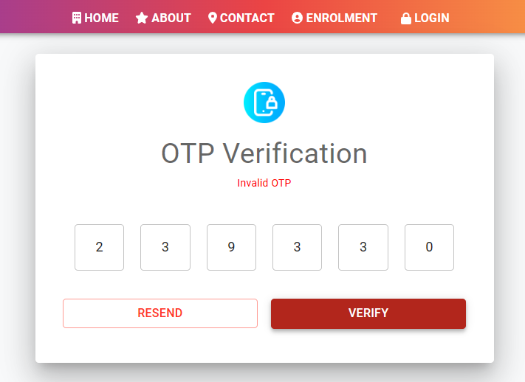

Figure 9: Invalid OTP

If a member does not receive OTP, the member can request to resend OTP only two times. If after 2 attempts, Resend button is pressed, the account gets blocked for 10 minutes and no new OTP is sent. (Figure 10)

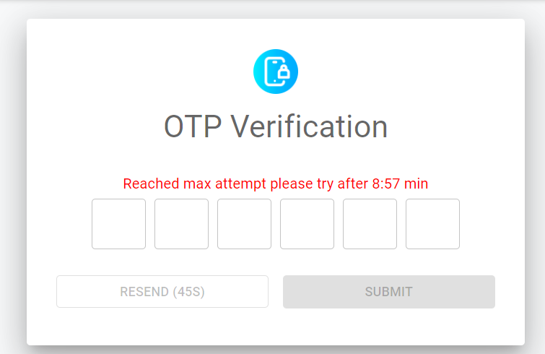

Figure 10: Resend OTP

## **2.4 MEMBER LOGIN**

Successful enrolment of the users enables them to subsequently login to the portal and perform the respective tasks as defined in the CMPFO processes. To login to the C-CARES portal:

1. Click on the Member Login. (Figure 11)
2. Member login page, as shown in figure 12, requires input fields like, Username (CMPF account number), Password and Captcha. The guidelines for the format of Username are also listed alongside.



Figure 11: Link to Member Login

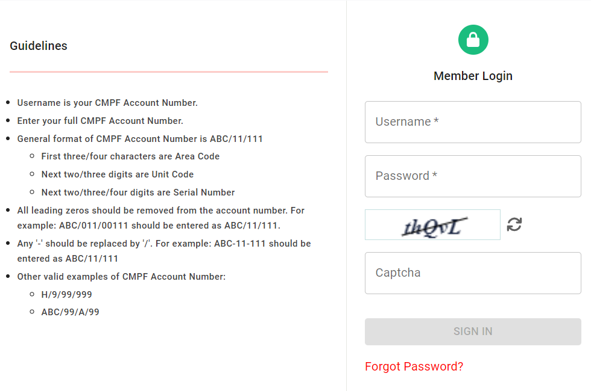

Figure 12: Member Login Page

1. After entering all the correct details, **SIGN IN** button is enabled. Click the **SIGN IN** button (Figure 13). On successful form submission, member is redirected to OTP verification page.

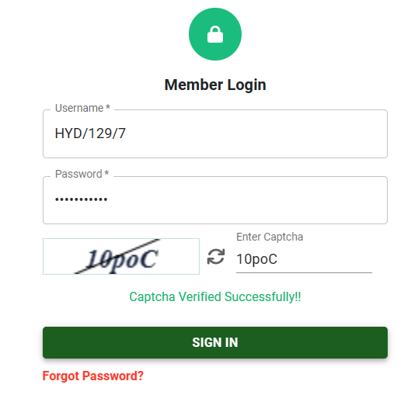

Figure 13: Sign In

1. An OTP is sent to the member’s registered mobile number. Enter the OTP correctly and hit the verify button. (Figure 14)

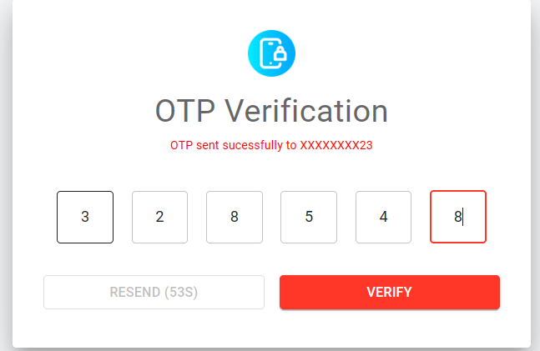

Figure 14: OTP Verification

1. On successful OTP verification, member is logged into his account and member dashboard opens as shown in figure 15. Member’s Account Summary is displayed by default.

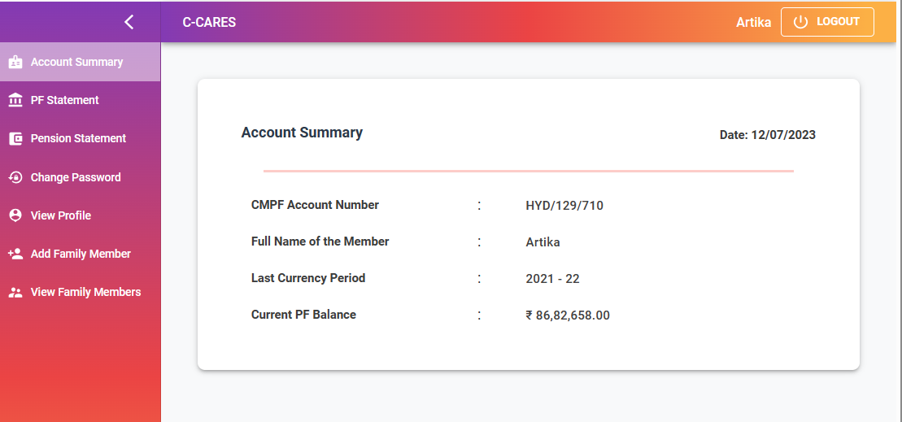

Figure 15: Member Dashboard

### 2.4.1 MEMBER LOGIN GUIDELINES

* + - 1. If username/password is incorrect a pop up comes to enter valid credentials.(Figure 16 and Figure 17)

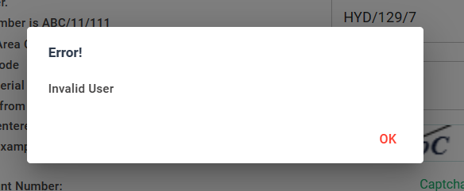

Figure 16: Invalid User

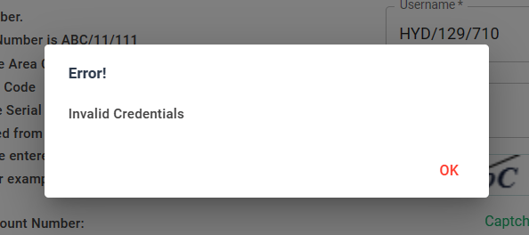

Figure 17: Invalid Credentials

* + - 1. A member has only three attempts to enter valid credentials, after that the member account is blocked for 24 hours and the message as shown is figure 18 is displayed.

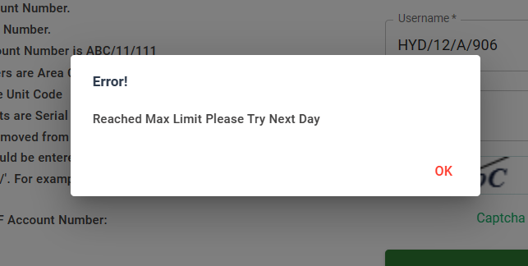

Figure 18: Account Blocked

* + - 1. The member can make maximum 3 attempts to enter correct OTP, after which he/she is blocked for 10 minutes. Each OTP is valid for 3 minutes. (Figure. 19)

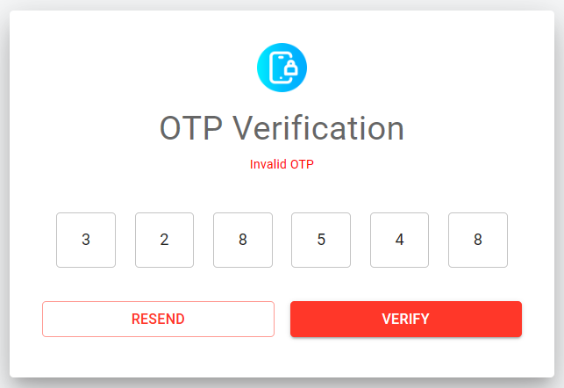

Figure 19: Invalid OTP

* + - 1. If OTP is not received, member can resend the OTP two more times after which the account is locked for 10 minutes as shown in figure 20.



Figure 20: OTP Blocked

# 3. Member dashboard

The member dashboard has 7 different functionalities which member can access just by clicking on them.

## **3.1 Account Summary**

Details such as CMPF Account Number, Full Name of the member, Last Currency Period and current PF Balance are displayed. (Figure 21)



Figure 21: Account Summary

## **3.2 PF Statement**

To view the PF Statement, member clicks on PF Statement tab on the side app bar. The member is redirected to the PF Statement page. By default last 10 transactions are displayed (Figure 22). To view more transactions, member can enter start and end year and click on View Statement, as shown in figure 23.

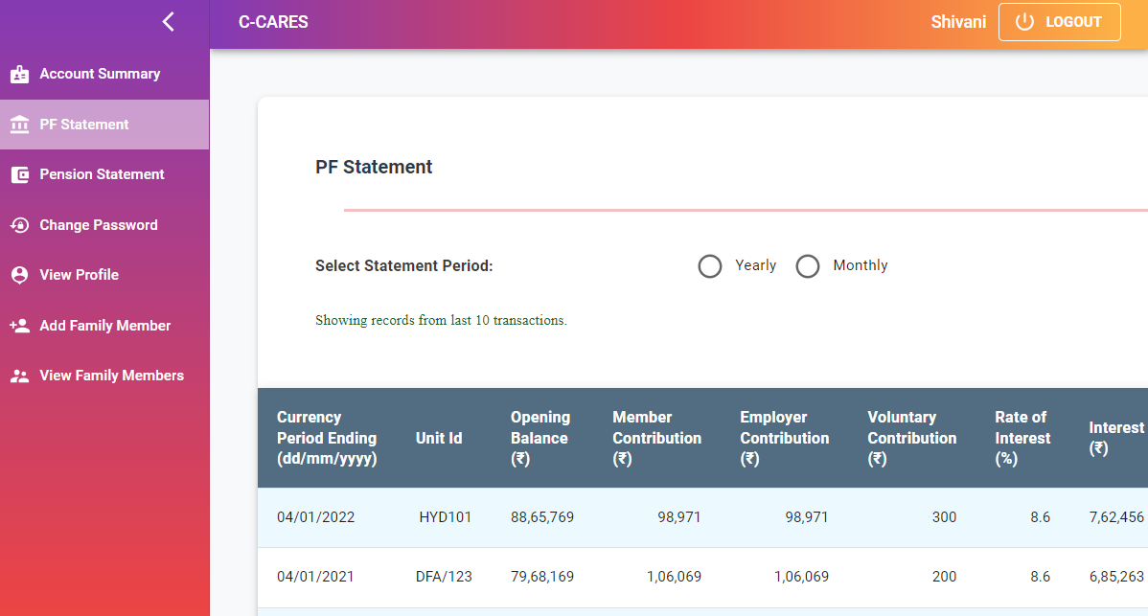

Figure 22: PF Statement

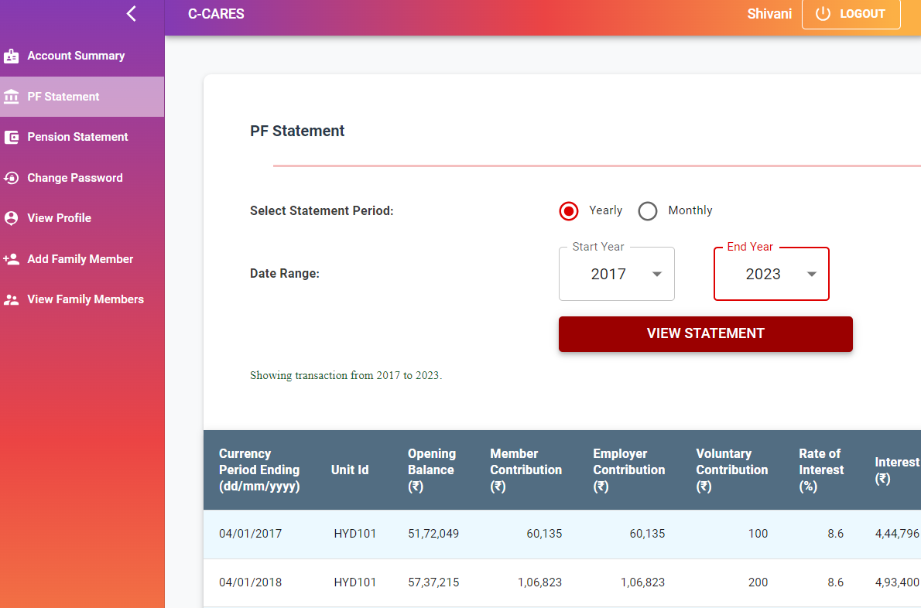

Figure 23: Detailed PF

### 3.2.1 Declaration of Correctness

In addition to viewing the PF statement, member has to verify the correctness of the information shown by giving his/her **“Declaration of Correctness”** at the bottom of the page. The member has to select either **“Correct”** or **“Incorrect”** as shown in figure 24.

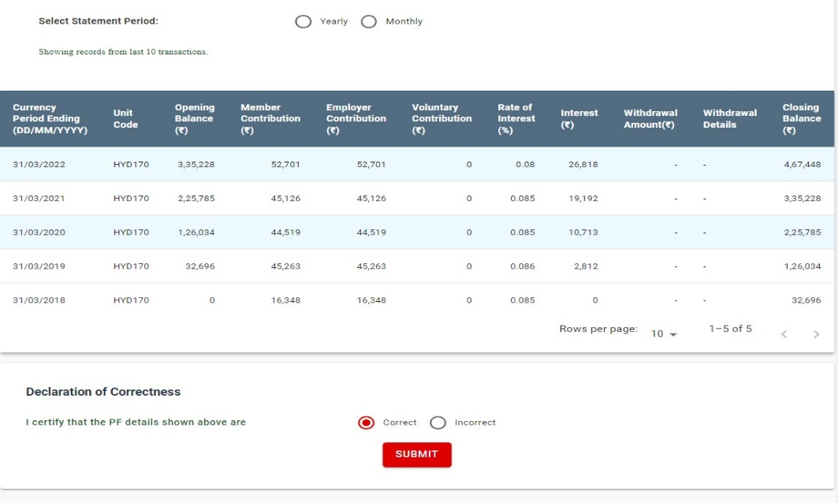

Figure 24 Declaration of Correctness

* **Correct:** If the member finds that information provided is correct, he/she can select this option and click on the submit button (Figure 24 and Figure 25).

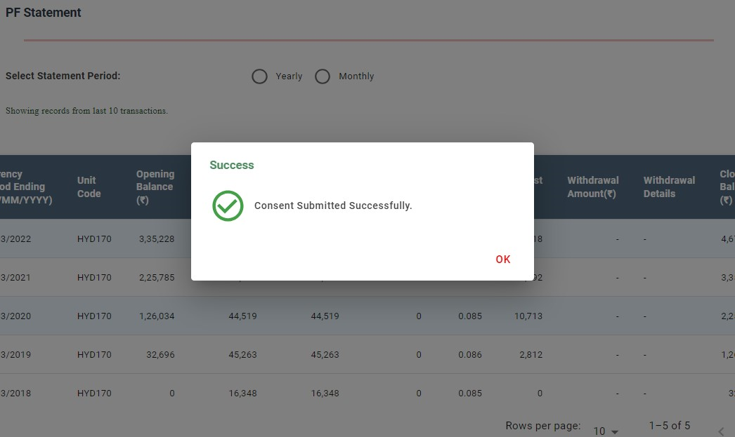

Figure 25: Consent Submitted Successfully

* **Incorrect:** If the member finds any missing/incorrect data, he/she can click on Incorrect option. In this case, a form needs to be filled by the member. The member is to provide specific information, including the start date, end date, unit code/unit name, regional office details, and any remarks they may have for the specified date range. If the member finds multiple discrepancies, he/she can click on the **‘Add Row’** button. This action will replicate the same form, allowing the user to fill in additional rows for incorrect data.

After filling the details the member has to submit the details (Figure 26). On clicking Submit button a pop message appears mentioning the successful submission of the details provided by the member (Figure 27).

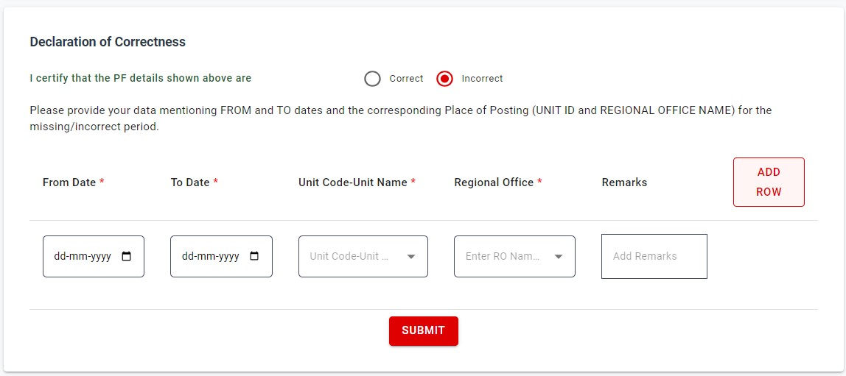

Figure 26: Details to be filled for missing/incorrect Data



Figure 27: Consent Submitted Successfully

## **3.3 Change Password**

* + - * Login to the member account (follow steps in section **2.4**). Click on Change Password tab. Change Password page is displayed. (Figure 28)
      * On entering details correctly and clicking CHANGE PASSWORD button, OTP verification page is displayed. (Figure 29)

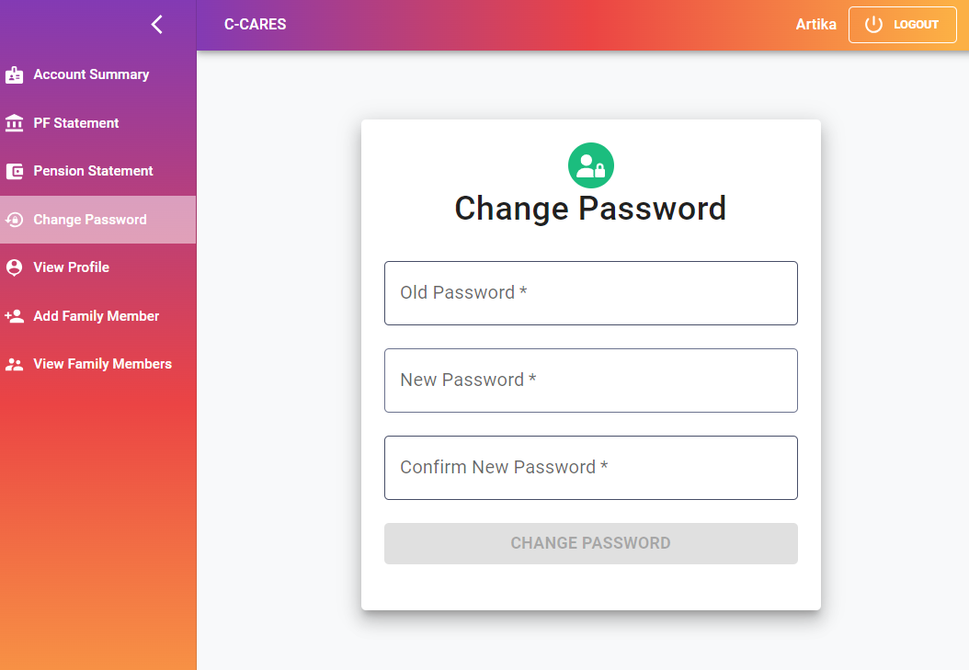

Figure 28: Change Password



Figure 29: OTP Verification

* + - * Enter the OTP correctly and hit the VERIFY button. (Figure 30)



Figure 30: Verify OTP

* + - * On successful OTP verification, pop up message comes for successful password change. (Figure 31)

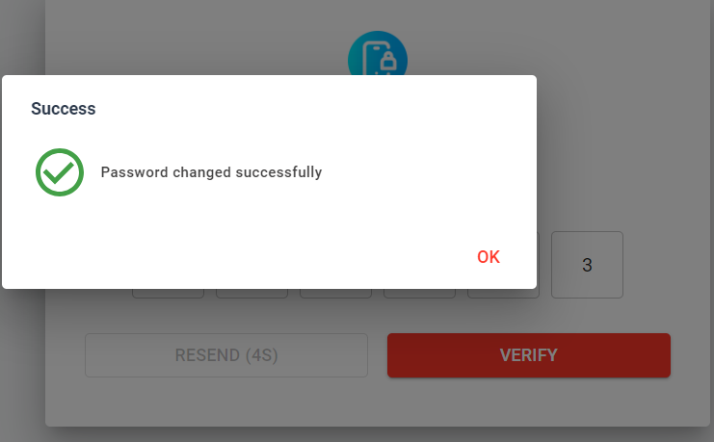

Figure 31: Password Change Success message

After successful password change, the member is logged out of his/her account and is redirected to home page and an email is sent on the registered email id of the member for successful password change.

### 3.3.1 Change Password Guidelines

1. New Password and Old Password cannot be same. If so error message pops up. (Figure 32)

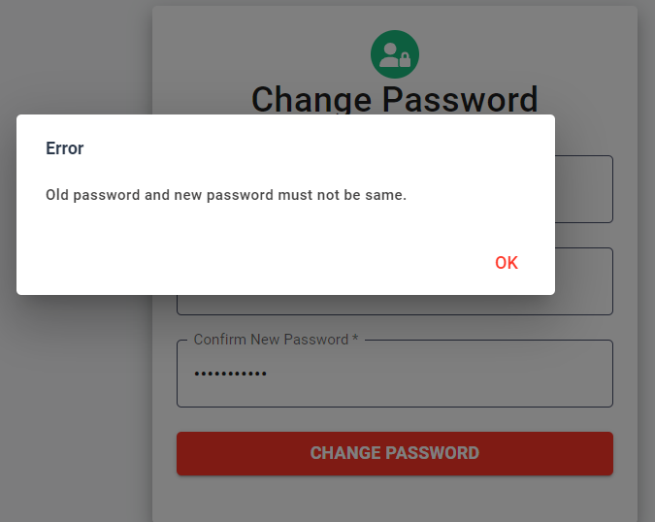

Figure 32: Error Message

1. For setting New Password, follow the password format described earlier in section **2.3.1.**
2. For any queries regarding OTP verification, refer to section **2.3.1** (steps 3 & 4).

## **3.4 View Profile**

Click on View Profile tab on app bar. Member’s personal details and employment details are mentioned here. (Figure 33)

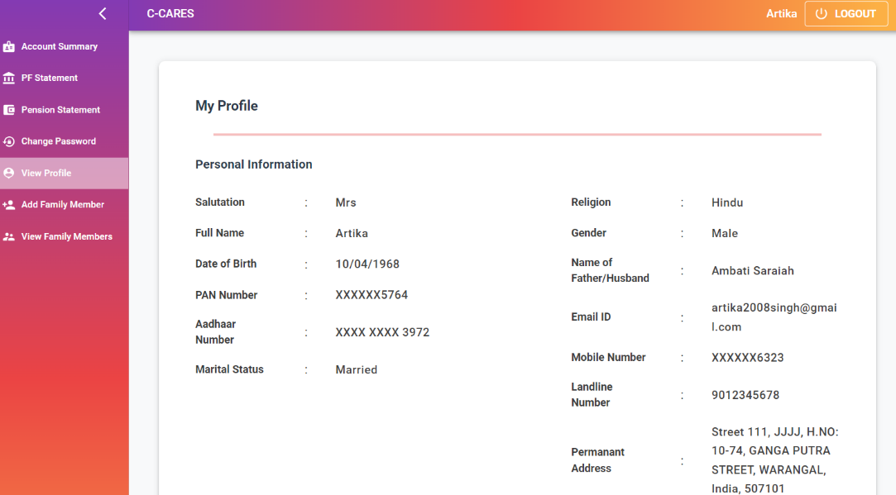

Figure 33: Member Profile

## **3.5 Add Family Member**

To be implemented in Phase - II

## **3.6 View Family Member**

To be implemented in Phase - II

## **3.7 FORGOT PASSWORD**

If member forgets the password, it can be reset using forget password feature.

1. Go to Member Login page. Below the **SIGN-IN** button one can find FORGOT PASSWORD written in orange. Click on it. (Figure 34)
2. Forgot Password page opens having **Login Id** field. Enter the correct login id/account no. and click on send OTP button. (Figure 35)

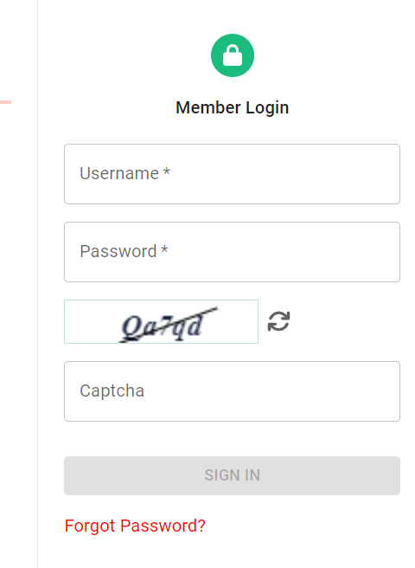

Figure 34: Forgot Password

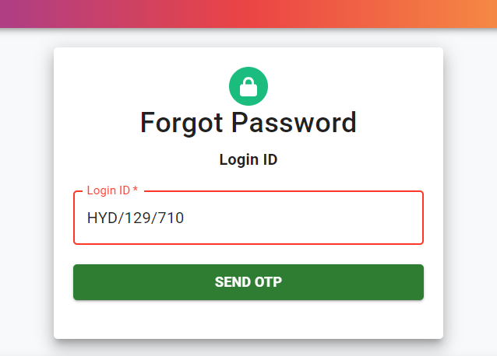

Figure 35: Login for Forgot Password

1. Enter the valid OTP and click verify button (Figure 36). On successful OTP verification, password reset page appears (Figure 37).



Figure 36: Verify OTP

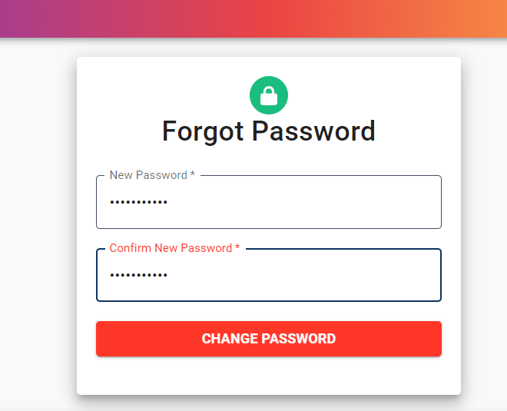

Figure 37: Set New Password

1. Enter the New Password in the fields given and click Change Password button. (Figure 37). For setting New Password, follow the password format described earlier in section **2.3.1.**
2. On success, a message is displayed stating “Password is updated” (Figure 38)

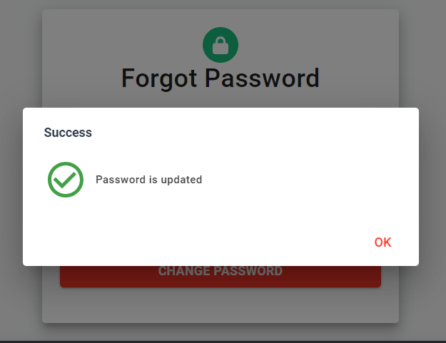

Figure 38: Password Updation

After successful password change, user/member is redirected to home page and an email is sent on the registered email id of the member for successful password updation.

### 3.7.1 FORGoT PASSWORD guidelines

1. New Password and Confirm Password should be same. If not error message is displayed (Figure 39).

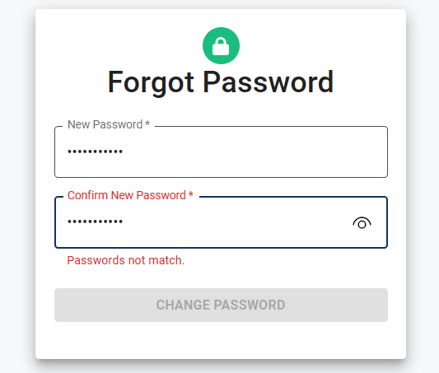

Figure 39: Forgot Password

1. For setting New Password, follow the password format described earlier in section **2.3.1**.

## **appendix**

**ANNEXURE-A: FREQUENTLY ASKED QUESTIONS**

**Q1.** What is C-CARES?

**A1**. It is a Centralized Digital Platform for CMPFO. It serves as a single access point for CMPFO and its regional offices to access the employees’ database as well as offer the requisite services to employers as well as employees w.r.t. PF, Pension and Advance claims and settlements.

**Q2**. How do I access C-CARES portal?

**A2.** Open any internet browser (i.e. Chrome, Microsoft Edge, Safari etc.) and type the following URL https://cmpfo.gov.in on the browser’s address bar to access C-CARES portal.

**Q3.** Can I access C-CARES account through the mobile as well?

**A3.** Yes. C-CARES web portal can be accessed on the mobile devices also.

**Q4**. Why am I not able to login to my account?

**A4**. Firstly, the member should be enrolled on the C-CARES portal. Only after successful enrolment a member can login to account. Make sure you are entering correct User Id and Password.

**Q5**. What is my User-Id?

**A5**. The CMPFO account number is the user-id/login id of the member. Using this account number, a member can enrol and/or login to the C-CARES portal.

**Q6**. How do I create a new account?

**A6**. A member can open account by enrolling himself on C-CARES portal.

**Q7**. What happens if I forget my login password?

**A7**. The member can reset his password by using the Forgot Password facility given in the member login page.

**Q8**. How many times can I login to my account in a day?

**A8**. A member can login any number of times in a day given that he logs in successfully in first two attempts every time he wants to access his account.

However, if he fails to login in third attempt, the account is blocked for 24hrs and it will automatically restored at 12:00 AM on the subsequent day.

**Q9**. How do I change my password?

**A9**. Login to your account. In the sidebar you can find Change Password tab. Click on it to change your password.

**Q10**. How can I view my account details online?

**A10**. Login to your account. By default, Account Summary is displayed to the member. This has the basic details of the member. Click on View Profile tab to see detailed information of the member.

**Q11**. What to do if my account is blocked?

**A11.** If account is blocked after invalid login attempt, it will restore automatically after 24hrs i.e. 12:00AM on the subsequent day.

**Q12**. How do I view my PF details?

**A12**. Login to your account. Click on PF Statement tab to see the PF details.

**Q13**. Why did my account logout automatically?

**A13**. There are two reasons for which a member is logged out of the account.

1. If he reloads the page.

2. If there is no activity on the webpage for 5 minutes

These measures are taken for the security of the member’s data.

**Q14**. Whom do I contact for assistance?

**A14**. In case of any ambiguity or doubts, users are advised to contact on below email addresses.

For Grievances: **grievance@cmpfo.gov.in**

For Other Queries/Information: [**support@cmpfo.gov.in**](mailto:support@cmpfo.gov.in)

